Noakhali Science and Technology University

Department of Information and Communication Engineering

**DIGITAL IMAGE**

**PROCESSING**

**LAB MANUAL 3**

Intensity Transformations

Prepared By: Md. Sabbir Ejaz

Lecturer, Dept. of ICE

Noakhali Science and Technology University

Department of Information and Communication Engineering

**Lab Objectives:**

The objective of this lab is to understand & implement

1. Image enhancement in spatial domain through Gray level Transformation function.
2. The effect of changing the number of gray levels on the quality of images.

**Image Enhancement in Spatial Domain:**

Image Enhancement in spatial domain (that is, performing operations directly on pixel values) is a very basic and simplistic approach. Enhanced images provide better contrast of the details that images contain. Image enhancement simply means, transforming an image *f* into image *g* using *T*. Where *T* is the transformation. The values of pixels in images *f* and *g* are denoted by *r* and *s*, respectively. As said, the pixel values *r* and *s* are related by the expression,

*s* = *T*(*r*)

where, *T* is a transformation that maps a pixel value *r* into a pixel value *s*. The results of this transformation are mapped into the grey scale range as we are dealing here only with grey scale digital images. So, the results are mapped back into the range [0*,L* − 1], where *L* = 2^*k*, *k* being the number of bits in the image being considered. So, for instance, for an 8-bit image the range of pixel values will be [0*,*255].There are three basic types of transformation functions that are used frequently in image enhancement. They are:

* 1. Logarithmic Transformation
  2. Power Law Transformation
  3. Piece Wise Linear Transformation

The transformation map plot shown in Figure 3.1 depicts various curves that fall into the above three types of enhancement techniques.

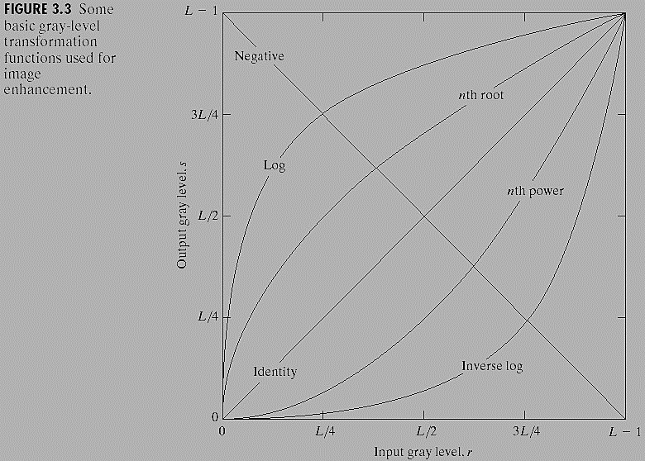

Figure 3.1

**Thresholding of an Image:**

Thresholding is a simple process to separate the interested object from the background. It gives the binary image. The formula for achieving thresholding is as follows:

*s = 0; if r ≤ t*

*s = L − 1; if r > t*

**Example:**

|  |  |
| --- | --- |
| **Algorithm** | **Matlab Code** |
| 1. Read a gray image. 2. Start with first row of the image. 3. Traverse all the column 4. Replace each cell value with 256 if cell value >128 5. Replace each cell value with 0 if cell value <128 6. Repeat 3,4,5 until last row of the image visited. | I = imread('cameraman.tif');  K= imfinfo('cameraman.tif');  [r,c] = size(I);  for i= 1:r % for each row  for j=1:c % for each column  if (I(i,j)>128)  I2(i,j) =256;  else  I2(i,j) =0;  end  end  end  figure,  subplot(121),imshow(I);  subplot(122),imshow(I2); |

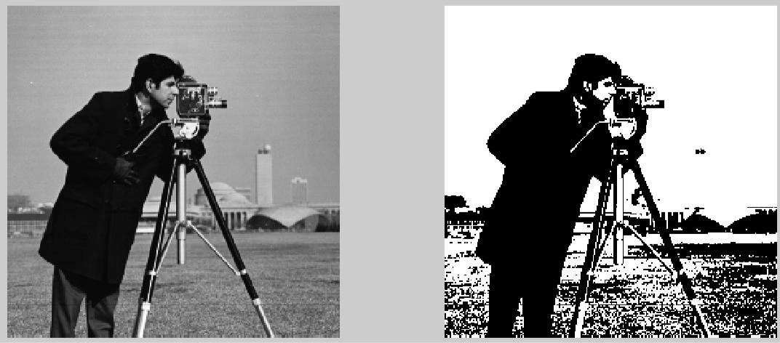

**Output 2 level Image (0 & 256)**

**Image Negation Function:**

The negative of an image with grey levels in the range [0, L−1] is obtained by the negative transformation shown in Figure 3.2, which is given by the expression,

*s = L − 1 – r*

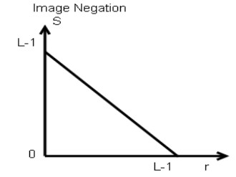

Figure 3.2

This expression results in reversing of the grey level intensities of the image thereby producing a negative like image. The output of this function can be directly mapped into the grey scale lookup table consisting values from 0 to L − 1.

**Log Transformations:**

It maps a narrow range of low intensity values in the input into a wide range of output levels. The opposite is true of higher values of input levels. It expands the values of dark pixels in an image while compressing the higher level values. It compresses the dynamic range of images with large variations in pixel values. For doing this you have to use-

*s = c log (1 + r)*

**Power Law (Gamma) Transformations:**

With fractional values(0<γ<1) of gamma map a narrow range of dark input values into a wider range of output values, with the opposite being true for higher values (γ >1)of input levels. C=gamma=1 means it is an identity transformations. Variety of devices used for image capture, printing, and display respond according to a power law. Process used to correct these power law response phenomena is called gamma correction. For doing this you have to use-

*s = c rγ*

**Bit Plane Slicing:**

This transformation involves determining the number of usually significant bits in an image. In case of a 8 bit image each pixel is represented by 8 bits. Plane 0 contains all the lowest order bits in the bytes comprising the pixels in the image & plane 7 contains all the high order bits. The higher order bits contain usually significant data and the other bit planes contribute to more subtle details in the image. Separating a digital image into its bit planes is useful for analyzing the relative importance played by each bit of the image.

|  |  |
| --- | --- |
|  |  |

**Practice Tasks:**

**TASK 1**

Write a MATLAB code that reads a gray scale image and generates the negative image of original image.

**Task 2**

Write Matlab program to-

1. Read a gray image. Then apply binary and inverse binary thresholding, where thresholding value=155 and display original, binary and inverse binary image in same figure.
2. Then, take a log transformation of original image
3. Take the power law transformation of gamma=5.0 & .02
4. Show b & c output in same figure with original input image.

**TASK 3**

Write a Matlab code to slice all the bit level of given image ‘lab3_a.tif’ and show each bit plane in same display.

**Task 4**

Write a Matlab program to read a color image file and display each component (R, G, B) image individually.

**Task 5**

Find out some image conversion function that can be used to convert one type image to another type image. Also apply these function on your image and show the result. [* use help of matlab documentation for your conversion functions].